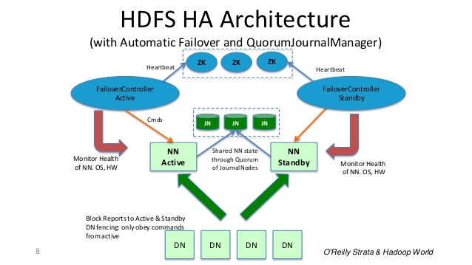
# HDFS HA ARCHITECTURE

